Name:Volodin Sergei
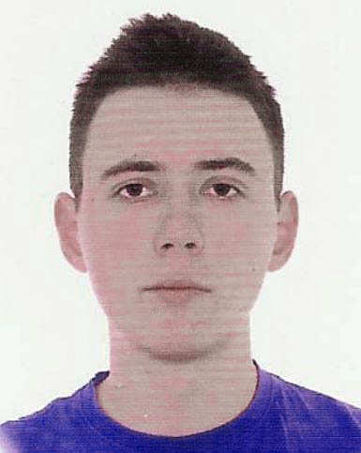

Contact Information
Address: Russian Federation, Moscow, 129346, Minusinskaya st., b. 1, app. 62
Tel: +7 916 600-90-58
Cell: +7 916 600-90-58
E-Mail: sergei.volodin@phystech.edu
Desired Research Intern Period at OIST: 2 months (2017/07/01 – 2017/08/31)
Desired Research Unit: Doya Unit

PERSONAL DETAILS
Date of Birth: 1994/10/03
Citizenship: Russian
Gender: Male

EDUCATION

Moscow Institute of Physics and Technology, BSc student (Russia, Moscow)
Department of Control and Applied Mathematics
Sub-department of Intellectual Systems and Data Analysis (major: machine learning)
Enrollment date: 2012/09
Expected graduation: 2017/06

EMPLOYMENT HISTORY
Skoltech, Center for Energy Systems, Research Intern, Sep 2016 – Present (Russia, Moscow)
- Worked on the Power Flow Feasibility problem with Assist. Prof. Anatoly Dymarsky and Dr. Elena Gryazina
- Designed (partially) and implemented the algorithm for cutting convex parts of the image in Matlab
- Examined the structure of the set of nonconvexities
MIPT, sub-department of Data Analysis, Student, Feb 2016 – July 2016 (Russia, Moscow)
- Worked on the ligand-receptor interaction problem using Machine Learning approach
- Implemented Probabilistic Classifier Chains algorithm using scikit-learn library
- Assessed this method as infeasible for the task
ITBrat. Developer. July 2015 – Feb 2016 (Russia, Moscow)
- Developed High Frequency Trading (cross-border arbitrage) application in C++, from initial discussion with the team to deployment and supporting
- Added low-level networking to the project using Solarflare OpenOnload library and hardware
- Designed and supported the environment for the algorithm: build stage, version control, performance analysis using network dumps
MIPT, sub-department of Theoretical Mechanics, Technician, Oct 2012 – Feb 2013 (Russia, Moscow)
- Worked on the article “Janibekov’s effect and the laws of mechanics” with A.G. Petrov
- Designed and implemented numerical simulations for Euler’s rotation equations
- Checked correctness of the approximation presented in the article using numerical simulation and symbolic computations in Wolfram Mathematica

OTHER QUALIFICATIONS
Skills
Languages: Russian (native), English (B2)
Programming: C/C++, Python, Matlab, scikit-learn, numpy, Mathematica, AVR C/C++, x86 assembly (nasm), Microsoft SQL
Courses
Getting Started with Deep Learning (NVIDIA Deep Learning Workshop, MIPT, Feb 2017)
Approaches to Object Detection using DIGITS (NVIDIA Deep Learning Workshop, MIPT, Feb 2017)
Conferences
Information Technologies and Systems. Speaker (Saint-Petersburg, Repino, September 2016)
Eights Traditional school Control, Information, Optimization. Poster presenter (Saint-Petersburg, Repino, June 2016)
Publications
Probabilistic prediction of nuclear receptors biological activity, S. Volodin, M. Popova, V. Strijov, ITAS 2016
Janibekov’s effect and the laws of mechanics, A.G. Petrov, S.E. Volodin, 2013, Doklady Akademii Nauk, 2013
Competitions
DeepHack.RL hackathon (Deep RL for Atari games), MIPT, 2017, 4’th place (z-score)
Scholarships
“Abramov fund scholarship” for excellent grades (2014)
INTERESTS
Machine learning, Artificial Intelligence, Optimization

